Project Design Phase
Problem – Solution Fit
Date | 27 September 2026
Team ID | SWTID-2026-7148
Project Name | AI Weatherwise API
Maximum Marks | 2 Marks

Problem – Solution Fit:
Problem-Solution Fit means identifying a real problem faced by your target customers and creating a solution that effectively addresses that problem. It helps entrepreneurs, marketers, and innovators understand customer needs, identify behavioral patterns, and develop solutions that are useful and practical.
Purpose:
- Develop solutions that match the actual needs and situations of customers.
- Improve solution adoption by using the channels and methods customers already prefer.
- Create clearer communication and marketing strategies based on customer needs.
- Build stronger customer relationships by addressing frequent, urgent, or costly problems.
- Understand the current challenges of the target group and identify opportunities for improvement.
- Find the right connection between customer problems, behavior, and the proposed solution.
- Build trust by providing solutions that create real value for customers.

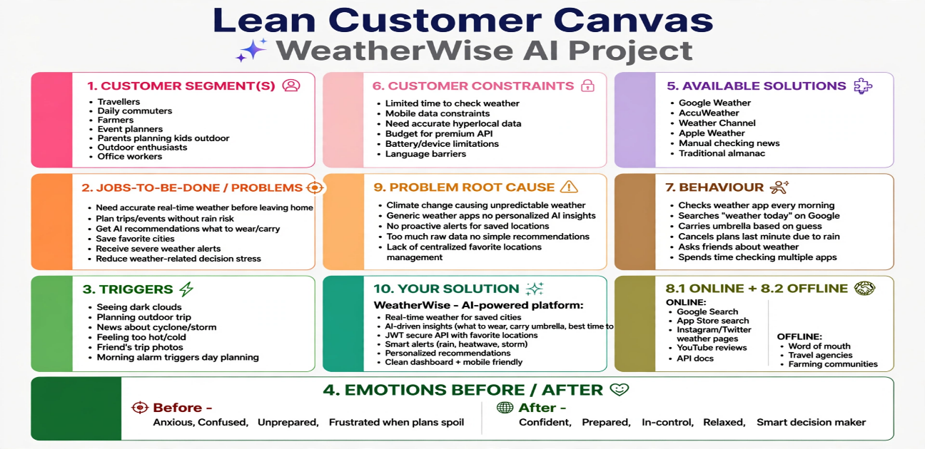
Reference
https://www.atlassian.com/agile/project-management
https://www.atlassian.com/agile/tutorials/how-to-do-scrum-with-jira-software

